**Lab3: Managing Hadoop Services**

**Objective: To use the Ambari Web UI to manage Hadoop services**

1. **Viewing Hadoop Services Configuration file:**

Hadoop service configuration files in the /etc/hadoop/conf directory

* [root@golden-node1 ~]# ls /etc/hadoop/conf
  + Hdfs-site.xml file is a default configuration file of HDFS or core hadoop

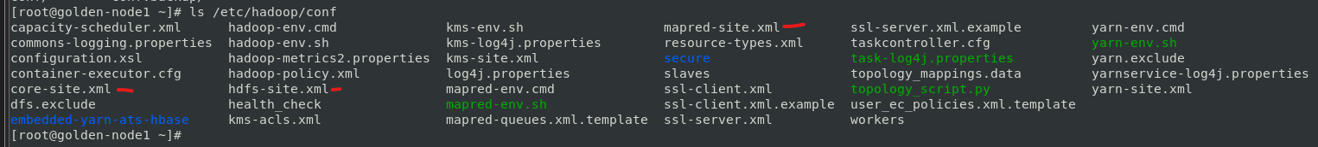

* [root@golden-node1 ~]# ls /etc/ambari-server/conf/



* [root@golden-node1 ~]# ls /etc/ambari-agent/conf/



* [root@golden-node1 ~]# ls /etc/hive/conf



* [root@golden-node1 ~]# ls /etc/pig/conf



* [root@golden-node1 ~]# ls /etc/zookeeper/conf



* [root@golden-node1 ~]# export PATH=$PATH:/usr/java/default/bin
  + Use the jar command for displaying the .jar file then set path in environment variable
* [root@golden-node1 ~]# jar tvf /usr/hdp/3.1.0.0-78/hadoop-hdfs/hadoop-hdfs.jar | grep xml



1. **Ambari Web UI Management and Configuration Features**

Go to Browser: golden-node1:8080

Username: admin

Password: admin

Go to Services 🡪 Select HDFS Service 🡪 Click on “NameNode UI” from the Quick Links

It will redirect to next page.

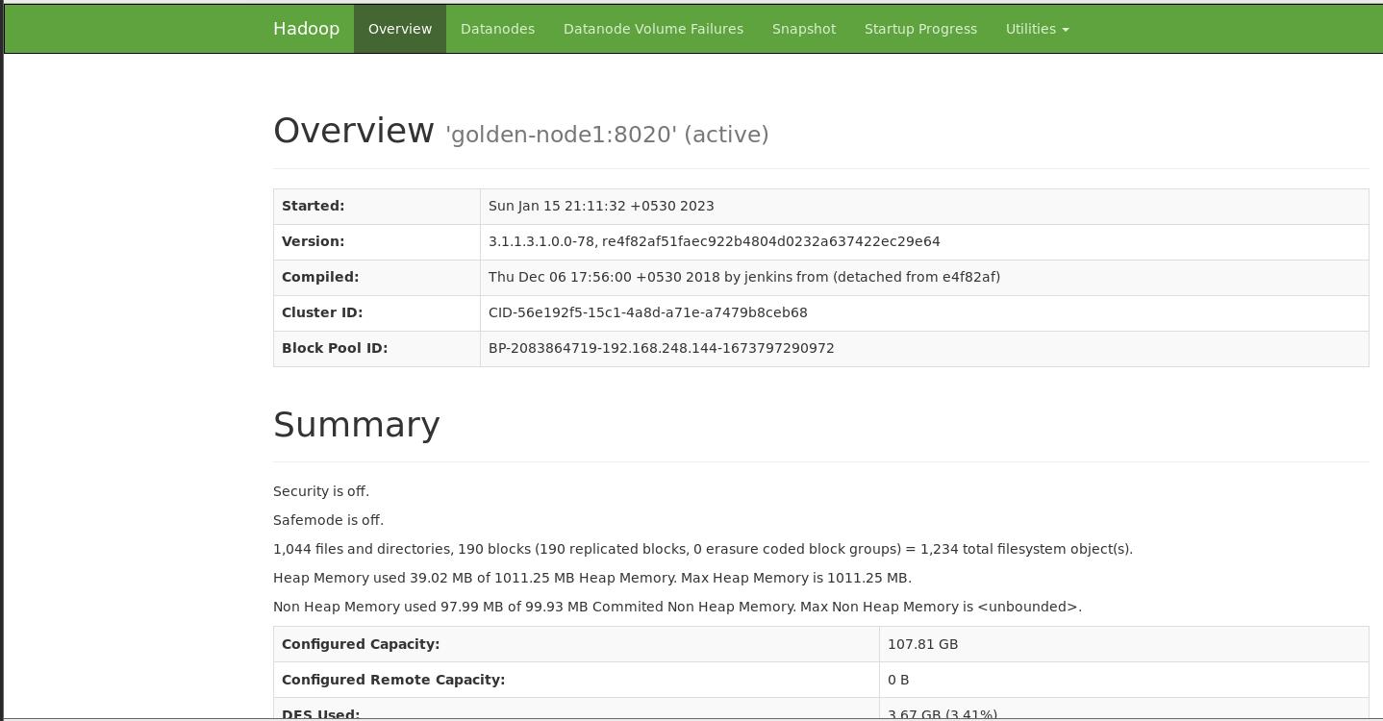

1. **Changing HDFS Service Configuration**

Go to HDFS 🡪 Select Config Tab

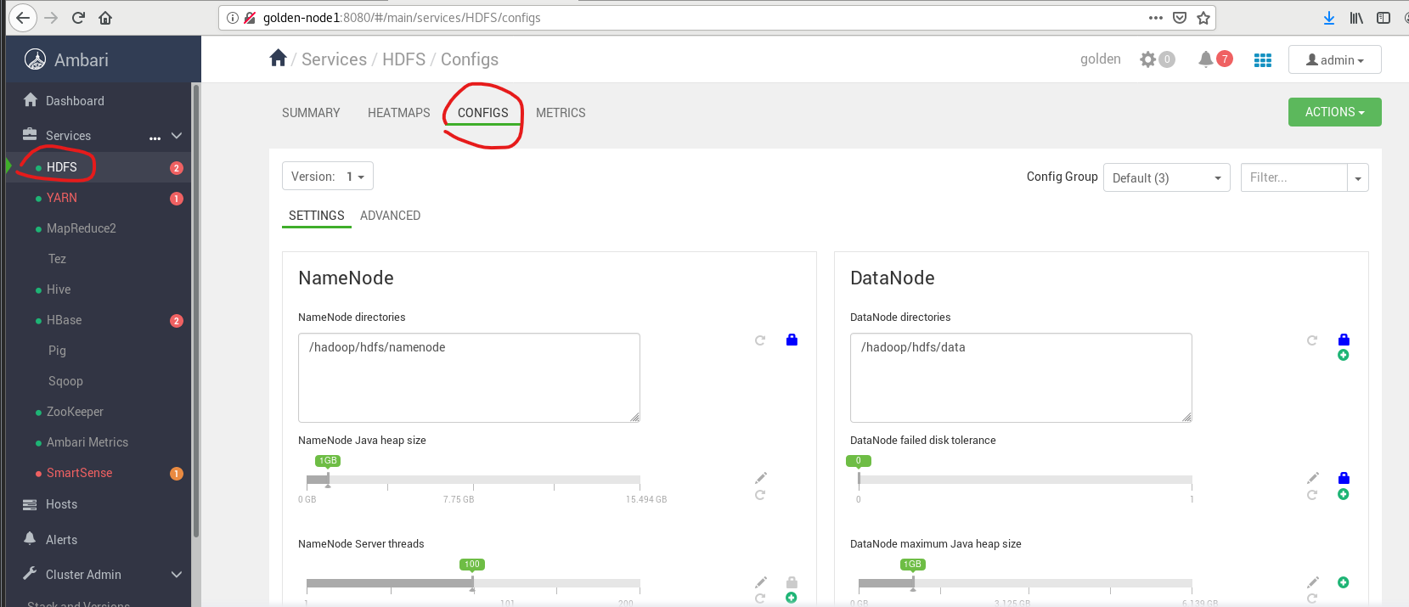

On the “SETTINGS” tab 🡪 Change NameNode Java heap size to 4 GB (Don’t Click on Save Button)

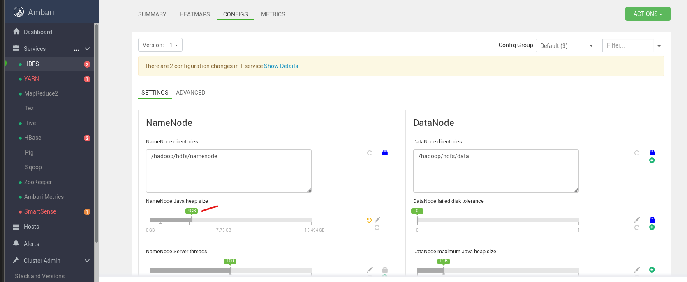

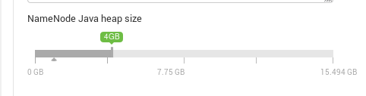

Go to “ADVANCED” tab 🡪 Click on “Advanced hdfs-site” 🡪 search dfs.replication.max (change its value from 50 to 40)

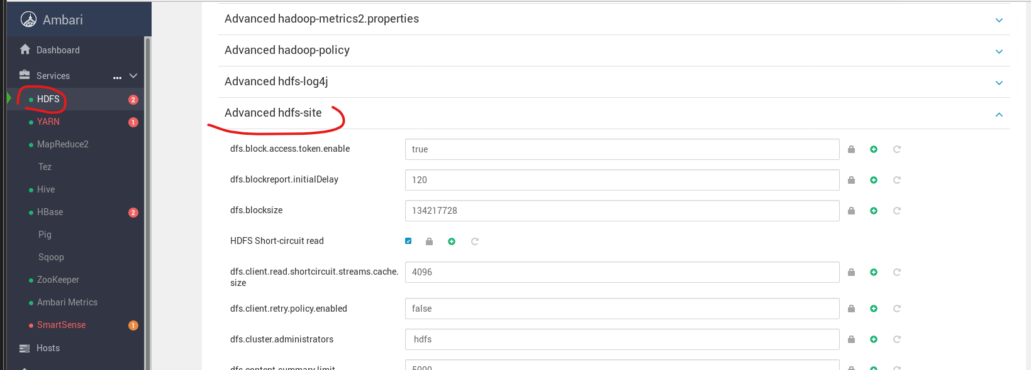

Before

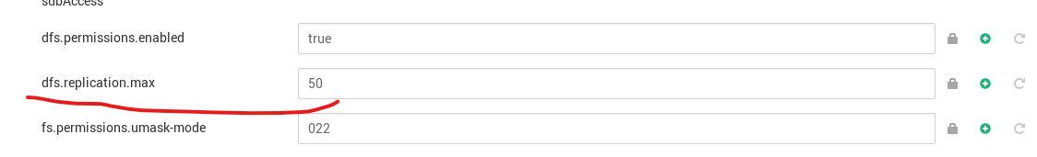

After

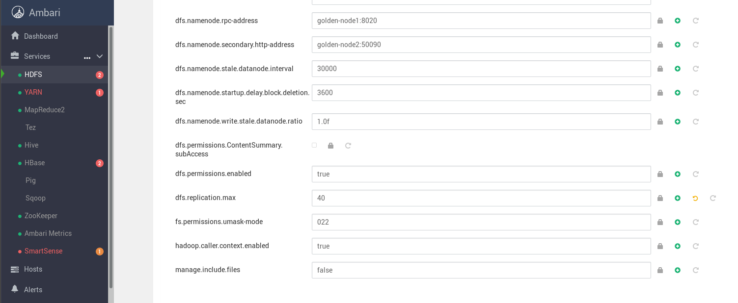

1. **Creating an Ambari Configuration Group**

Go to HDFS Tab

Click on CONFIG 🡪 Select “Manage Config Groups” from Config Group

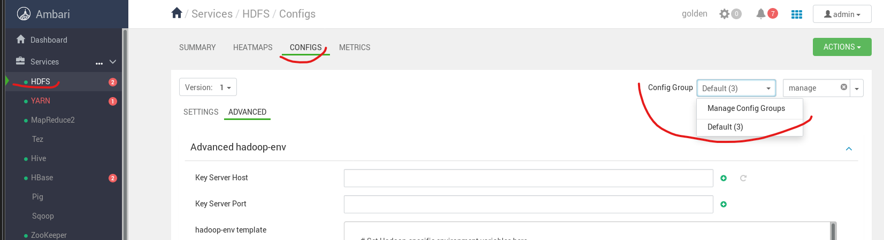

Click on + sign for Creating a new configuration group

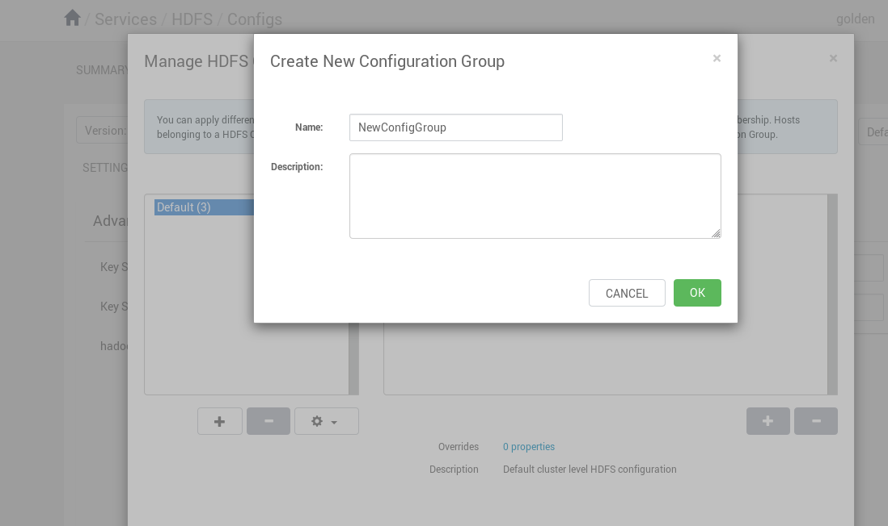

Not Completing This Lab yet